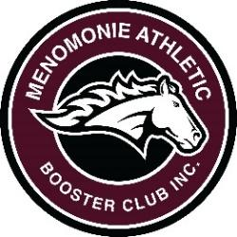
2023-24 MABC, INC. MEMBERSHIP
Join the Menomonie Athletic Booster Club today!

MABC contributes to ALL athletic programs. To date,
over $700,000 has been donated to MHS athletic programs.

Name – As you want it to appear in the program insert

Phone number Email

Address

Senior athletes are eligible for the MABC scholarship if they have a parent or grandparent who is an active (paid) club member. Please list children or grandchildren you have at MHS that will be graduating in 2024.

All memberships include invitations to MABC sponsored events, a MABC decal, and your name included in home sports program inserts. All gifts carry the MABC logo. Please note that gifts are no longer cumulative.

- BRONZE: $1-$49
- SILVER: $50-$99 - all silver members will receive a MABC can koozie
- GOLD: $100-$199 circle one cooler umbrella none
- PLATINUM: $200-$499 circle one tote blanket none
- GOLD: $500+ circle one jacket sweatshirt none
indicate size______

Memberships run from July 1, 2023 – June 30, 2024
Please make check payable to Menomonie Athletic Booster Club, Inc. and send with this form to:

Menomonie Athletic Booster Club, Inc Or Pay Online: www.menomonieathleticboosterclub.com
c/o Kathy Weber
E4530 458th Avenue
Menomonie WI 54751

If you have any questions, please contact one of the following MABC board members:

Andy Lamb, President/Nik Shepard, Vice-President
Kathy Weber, Secretary/Andrea Gores, Treasurer

Please join us at the Stout Craft Co for our monthly meetings
at 6:00 pm on the second Wednesday of each month!

